DBMS: LAW MANAGEMENT SYSTEM

INTRODUCTION:-

A law management system, also known as a legal practice management system (LPMS) or law practice management software, is an all-encompassing software solution created to simplify and improve the operations of law firms, legal departments, or individual attorneys. In order to successfully manage their cases, clients, papers, appointments, billing, and other administrative responsibilities, legal businesses rely heavily on this system.

The legal profession is inherently complex and necessitates meticulous planning, adherence to rules, and good client and legal professional communication. These issues are specifically addressed by law management systems, which offer a single platform to manage the numerous activities that attorneys and other legal professionals must deal with on a daily basis.

SCOPE OF CASE STUDY

* The legal system in India works through a combination of traditional law practices and modern technologies. A law management system includes many elements such as **Lawyer**, **Client**, **Court**, **Case** and **Document**.
* Lawyers are legal professionals who provide legal advice, represent clients in court, and assist with legal issues, contracts, and legal documentation. a lawyer handles many cases. it comprises the **Lawyer id**, **Name**, **Mobile number**, **Specialization**, **Bar license number** and **Hire date** also.
* Clients can be individuals or entities (such as businesses) who initiate or defend a lawsuit. clients include a **Unique** **id**, **Name**, **Address**, **Mobile** **number**.
* Courts are the formal legal systems in which cases are heard and resolved. lawyers present arguments, evidence, and seek legal remedies or justice on behalf of clients in court. court includes the **Court id**, **Name** and **Address**.
* There are undoubtedly many types of cases that include criminal, civil, family law, traffic violations cases and so on. each and every case has its own **Case id**, **Name**, **Description**, **Status**, **Date opened** and **closed.**
* Court related document include pleadings, evidences, court orders, summons, transcripts, briefs judgements and legal notices to make every document different from another document has **Document id**, **Name**, **Type**, **Declared Date.**

**ENTITIES AND THEIR ATTRIBUTES**

1. **LAWYER:** This entity represents lawyers or legal professionals who work within the system. (**LAWYER_ID**, FIRST_NAME, LAST_NAME, PHONE, SPECIALIZATION, BAR_LICENSE_NUMBER, HIRE_DATE)
2. **CLIENT:** Represents the clients or individuals involved in legal cases.

(**CLIENT_ID**, FIRST_NAME, LAST_NAME, ADDRESS, MOBILE_NO)

3. **CASE:** Represents legal cases that lawyers handle.

(**CASE_ID**, CASE­_NAME, CASE_DESCRIPTION, CASE_STATUS, DATE_OPENED, DATE_CLOSED)

**4.COURT:** The courts where legal cases are heard. **(COURT_ID**, COURT_NAME, ADDRESS)

**5.DOCUMENT:** Represents documents or records associated

with legal cases.

**(DOCUMENT_ID**, DOCUMENT_NAME, DOCUMENT_TYPE , DATE_DECLARED)

ER -DIAGRAM

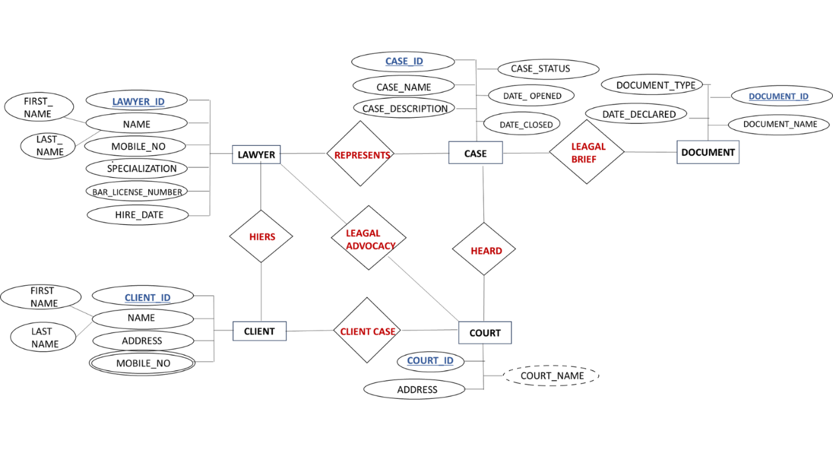

**RELATIONSHIPS**

* **LAWYER-CASES RELATIONSHIPS** (**One-to-Many**): Each lawyer can handle multiple cases.
* **CLIENT-COURT RELATIONSHIPS** (**One-to-Many**): Each client can be associated with multiple cases, as clients can be involved in various legal matters.
* **CASE-DOCUMENTS RELATIONSHIPS(One-to-Many)**: Each case can have multiple legal documents associated with it.
* **LAWYER-COURT RELATIONSHIPS**(**Many-to- Many**): A lawyer can be associated with multiple courts, and a court can have multiple lawyers associated with it.
* **LAWYER-CLIENT RELATIONSHIPS** (**One-to-Many**): Each lawyer can represent multiple clients, but each client is typically represented by one lawyer at a time.
* **CASE-COURT RELATIONSHIP** (**Many-to-One**): Each case is associated with one specific court where legal proceedings related to that case take place.

TABLES

**1.LAWYER** (**Lawyer_id** , First_name , Last_name , mobile_no, Specialization, Bar_license_number, Hire_date)

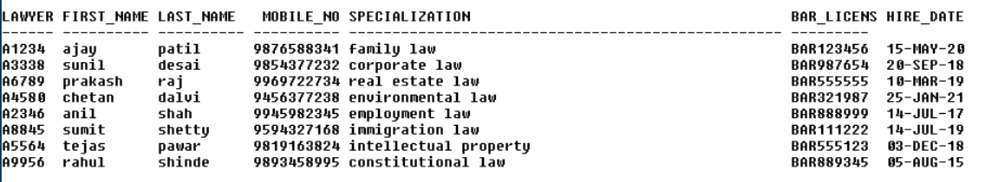

2. **CLIENT** (**Client_id** , First_name , Last_name , Address, Mobile_no )

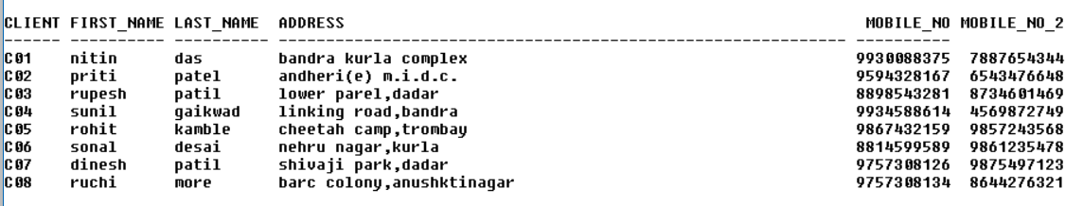

3. **COURT** (**Court_id**, Court_name, Address)

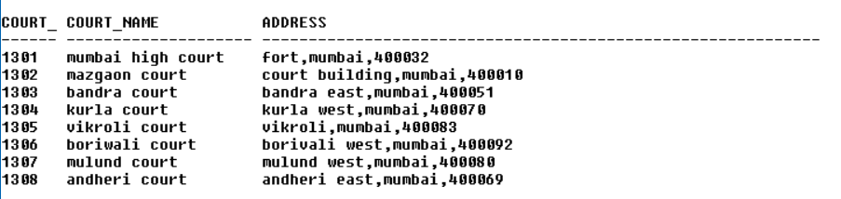

**4.CASE1** (**Case_id**, Case­_name, Case_description, Case_status, Date_opened, Date_closed, **Lawyer_id**, **Client_id**, **Court_id**)

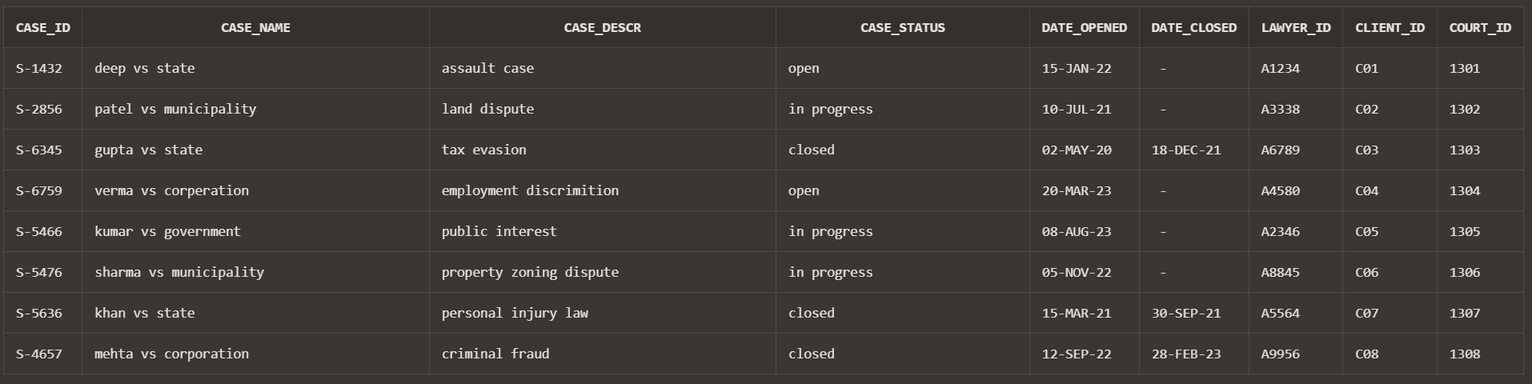

**5.DOCUMENT** (**Document_id**, Document_name, Document_type, Date_declared, **Case_id**)

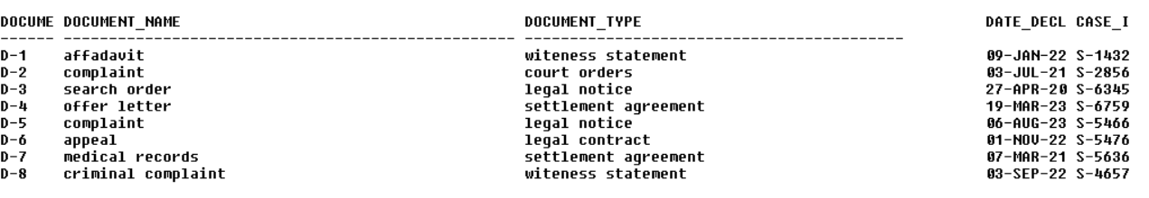

QUERIES

**1) Find the names of all Document:**

SELECT DOCUMENT_NAME FROM DOCUMENT;

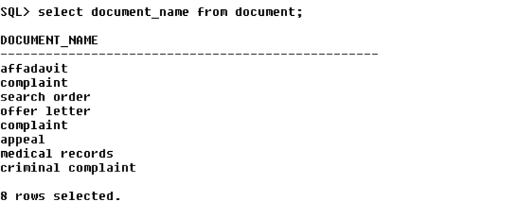

**2) Change the address of CLIENT_ID ‘C07’ to ‘PRABHADEVI,DADAR’.**

UPDATE CLIENT

SET ADDRESS = ‘PRABHADEVI DADAR’ ;

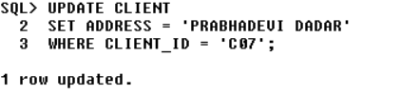WHERE CLIENT_ID = C07;

**3)SELECT * FROM LAWYER where mobile_no like’98%**

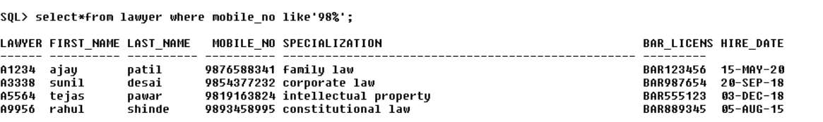

**4) Change the name of COURT to COURT_OF_JUSTICE.**

ALTER TABLE COURT

RENAME TO COURT_OF_JUSTICE;

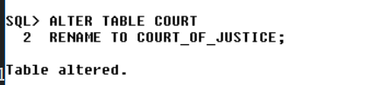

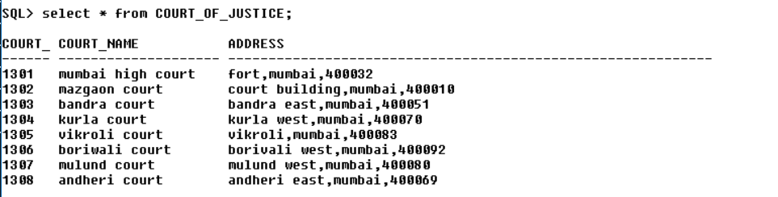

**5) Find the cases of ‘In Progress’ that started before 2023.**

SELECT *FROM CASE1WHERE UPPER(CASE_STATUS) = 'IN PROGRESS' AND DATE_OPENED < TO_DATE('2023-01-01', 'YYYY-MM-DD')



**6) List all case started dates in format ‘DD-Month-YY from CASE table.**

SELECT TO_CHAR(DATE_OPENED, 'yyyy-mm-dd') AS "DATE_OPENED" FROM CASE1;

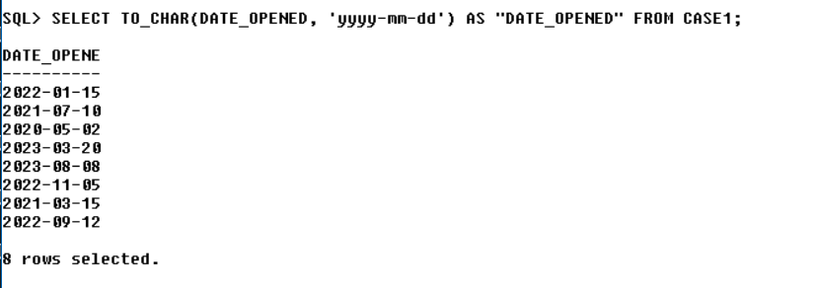

**7)Display case id and description with lawyer id and his Name**

**Select case1.case_id,**

**case1.case_descr,**

**lawyer.lawyer_id,**

**lawyer.first_name AS lawyer_first_name,**

**lawyer.last_name AS lawyer_last_name**

**FROM case1**

**INNER JOIN lawyer**

**ON lawyer.lawyer_id = case1.lawyer_id;**

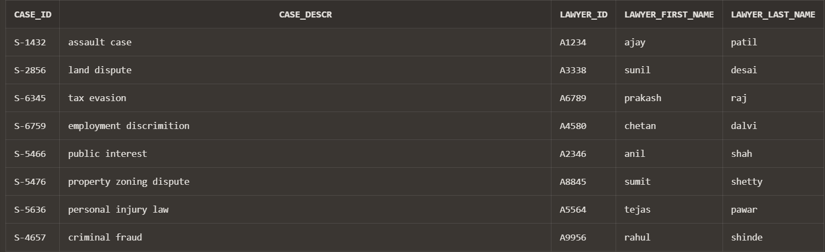

**8)**Count total number of court with court name in ascending order from court

SELECT court_name, COUNT(*) AS total_court

FROM court

GROUP BY court_name

ORDER BY court_name ASC;

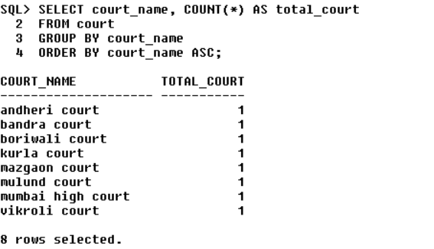

9) **Display document type starts with l and how much they are present**

SELECT document_type , count(*) as document_no

FROM document

WHERE document_type LIKE ‘l%’

GROUP BY document_type;

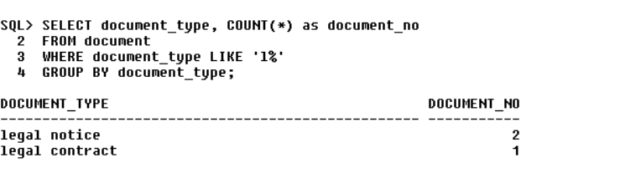

10) Display first name of client where his mobile number ends with 1

select first_name from client where mobile_no = ( select mobile_no from client where mobile_no like '%1');

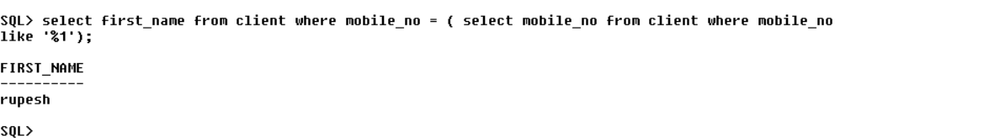

PROCEDURE

1) declare

v_id lawyer.lawyer_id%type;

v_firstname lawyer.first_name%type;

v_number lawyer.mobile_no%type;

begin

v_id:='&v_id';

select first_name , mobile_no into v_firstname , v_number from lawyer where lawyer_id=v_id;

dbms_output.put_line('lawyer name is:'||v_firstname);

dbms_output.put_line('mobile number is:'||v_number);

end;

/

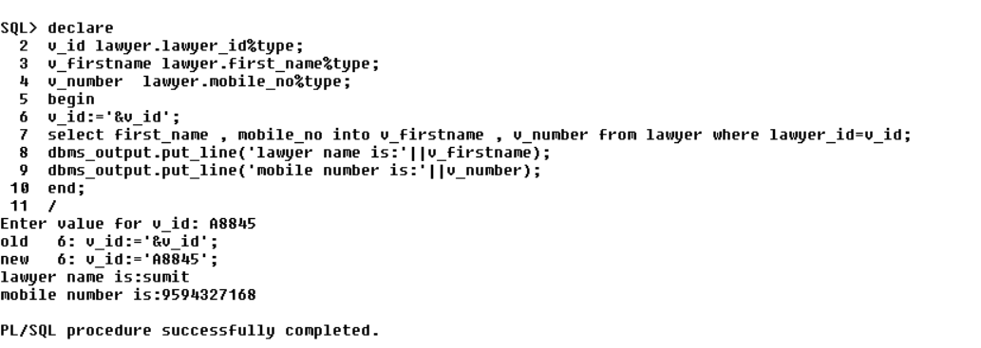

**FUNCTION**

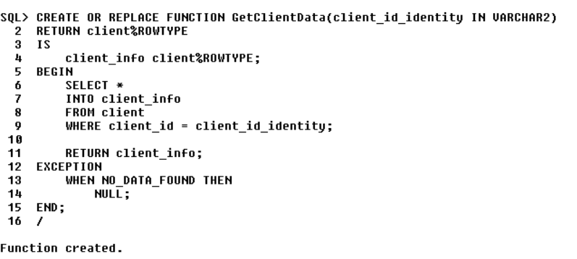

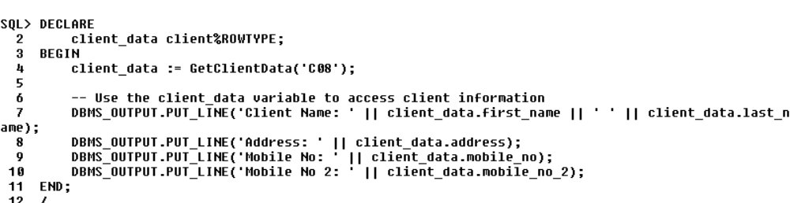

OUTPUT:

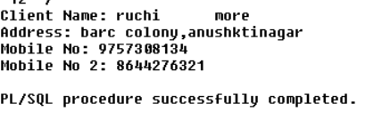

TRIGGER

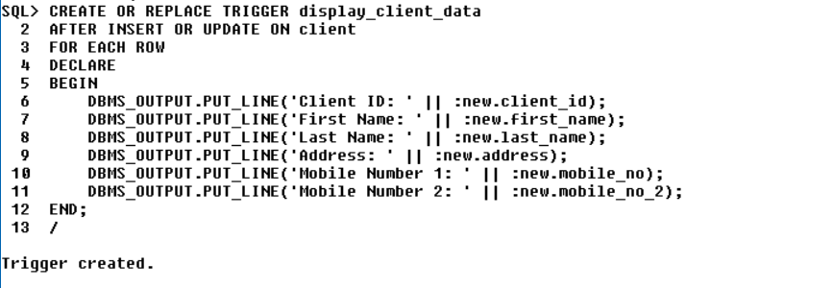

OUTPUT:

